Practical - 4

**AIM : Introduction of Docker set-up and study of basic docker commands.**

Setting up Docker on a Linux system and learning some basic Docker commands is a valuable skill for containerization and managing software applications. Perform the following tasks:

Task 1: Install the Docker Command Line Interface Tool from: <https://docs.docker.com/desktop/>

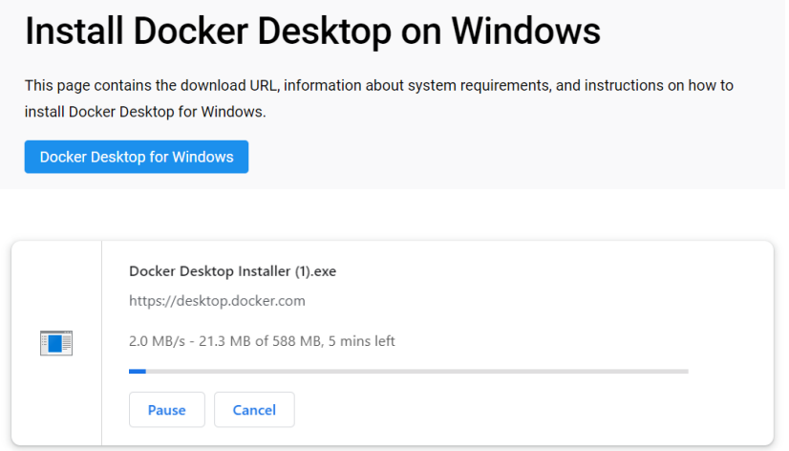

Task 2: Hands-on on docker commands:

● Execute the different docker commands to work pull the image from the docker hub and run the image in your local system.

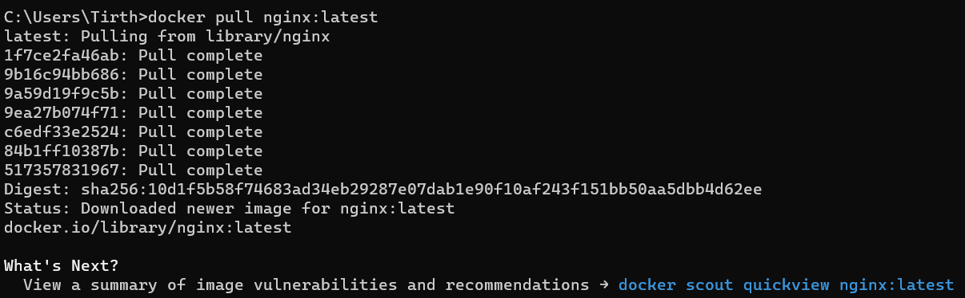

● Commands to run the container with the name of your choice

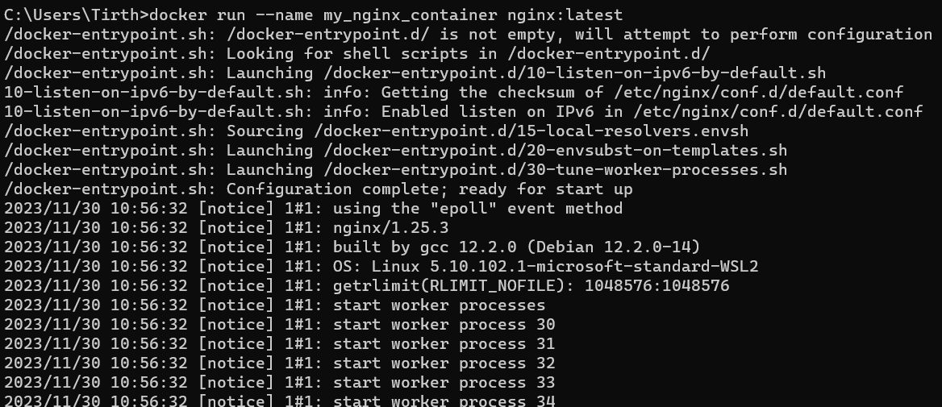

● Command to detach and attach the container

➢ To run a container in the background (detach):



➢ To reattach to a detached container:

$ docker attach detached_container

● Command to list all the images and containers

➢ list all the images

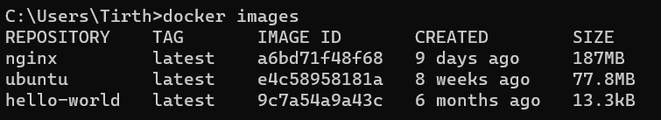

➢ list all the containers

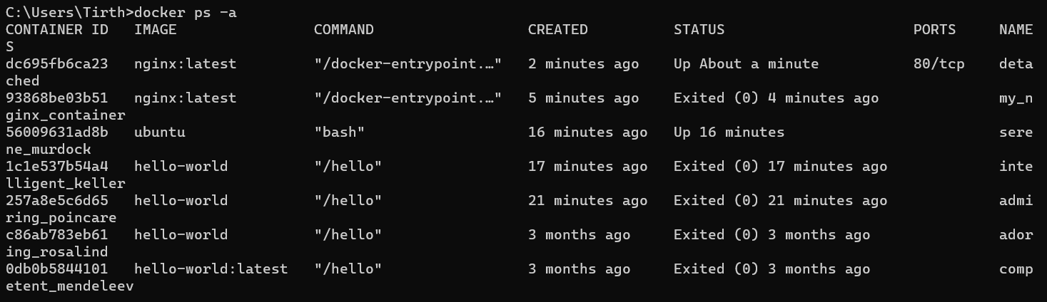

● Command to delete the specified image and containers

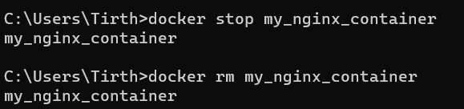

● Delete all the containers

